

**A211 STIA1113 PROGRAMMING 1 (GROUP C)**

LECTURER : Prof. Madya Dr. Azman B Yasin

NAME : Muhammad Yasri Bin Roslan

MATRIC NUMBER : 287021

TOPIC : Bank

SUBTOPIC : Housing Loan

1. **Identify the problem**

A home loan also known as a mortgage is a contract between a borrower and a lender that allows the borrower to borrow money to purchase a home, apartment, condo, or other living property. A home loan is often repaid over 10, 15 or 30 years. The majority of people consider buying a home to be the most important financial decision they will ever make. Most people can't afford to pay cash for the entire property up front because residences can cost hundreds of thousands, if not millions, of dollars. As a result, they will need to obtain a house loan which borrow from a bank, credit union, or specialty mortgage lender for low-income borrowers such as CIMB Bank, Maybank or Bank Islam. For example Maybank is Malaysia’s largest financial services group and has a strong regional presence in South East Asia. Maybank offers a full range of financial products and services covering consumer banking, corporate and investment banking, Islamic banking, asset management, wealth management, insurance and takaful, and private banking. All of this is a importing thing to people to gain their loan to buy property or to invest for future. The situation that we can see is that new borrowers are hesitant to apply for a loan because they are unsure of how much they will have to pay if they apply for one and how much their entire total payment would be, including interest, throughout the life of the contract.

1. **Understand the problem**

Due to applicants' lack of awareness of the process, home loan applications in Malaysia have a high incidence of denial. According to Bank Negara Malaysia, home loan refusal rates reached nearly 60% last year (BNM). This is because many borrowers are uninformed of how much they can borrow and what they must remember to avoid their loan being rejected by the bank. This is a problem that many borrowers, particularly first-time borrowers, experience. The majority of them always apply for a loan based on the price of the home they want, but they overlook variables such as the amount they must repay. This is critical because when a borrower purchases a home without first calculating the amount they must repay, it can cause certain borrowers to have difficulty repaying their loans, and in some cases, this can lead to bankruptcy. . As a result, borrowers must understand how to determine the amount owed and the overall amount owed on the contract.

1. **Identify alternative ways to solve the problem**
2. Make a system calculating for help borrower to calculate their amount of payback and the total amount payback in housing loan.
3. Make system to give a information for borrower to know more about housing loan applying.
4. **Select the best way to solve the problem from the list of alternative solution**

The best way to solve this problem are first way which is make a system calculation for help borrower to calculate their amount of they need to pay. This is because when borrower know how much they need to pay for monthly so they can find a house price that suitable with they salary. Next this calculation will help a lot to borrower especially for borrower who are the first time borrow loan from the bank because it can reduce a time for borrower deal with a banker about a amount. Also when borrower buy a house that can they able to pay this can make a low risk for borrower bankrupt.

1. **List instruction that enable you to solve the problem using the selected solution**
2. Borrower need to declare some information
3. The system will help borrower to calculate the total of amount according the information in the first part
4. The system will give the total amount of payback and also they total amount in the term of contract

**The calculation**

|  |  |  |
| --- | --- | --- |
| **NO** | **LOAN TERM** | **TOTAL** |
| 1. | Principal | Rm 249,000 |
| 2. | Interest rate  3.80 / 12 / 100 | 3.80 / 12 /100  0.00031 |
| 3. | Term of years  Years * 12 | 30 * 12  360 years |
| 4. | Monthly payment  249,000 * 0.31(1+ 0.31) * 30 years  (1+ 0.31) 30 years - 1 | Rm 1160 |
| 5. | Total Payment in contract  Total monthly payment * term of years * 12 | Rm 417,684 |

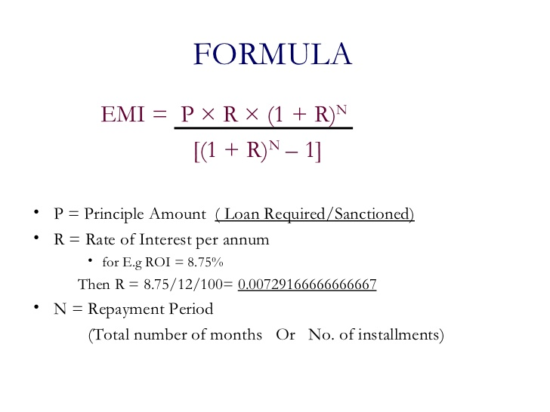

1. **Evaluate the solution**

In the end of this system will help the borrower budget planning to buy a house because they already know how much the total they need to payment. This also make a borrower feel save to apply loan to the bank.

1. Algorithm
2. Start
3. Enter the name
4. Enter the loan amount
5. Enter the interest rate
6. Enter the number of years
7. The system will calculate the monthly payment and the total of payment
8. End
9. Pseudocode
10. START
11. Read the name
12. Read the loan amount
13. Read the interest rate
14. Calculate the monthly interest rate
15. Read the number of years
16. Calculate the monthly payment = loan * monthly interest (1-monthlyinterest)*years / (1+ monthlyinterest , years)-1
17. Calculate the total payment = monthlypayment * years
18. The system will come up with the total monthly payment and the total payment
19. END
20. Flowchart

START monthlypayment * years

Declare name

Declare loan amount

Declare interest rate

Monthly interest =

interest */12/100

Declare number of years

Years *12

Calculate the monthly payment

loan * monthly interest (1-monthlyinterest)*years / (1+ monthlyinterest , years)-1

Calculate the total payment

monthlypayment * years

Print the total for monthly payment and total payment

END

1. **Coding**

**package** ASSIGNMENT1;

**import** java.util.Scanner;

**public** **class** houseLoan {

**public** **static** **void** main(String[] args) {

// **TODO** Auto-generated method stub

Scanner sc = **new** Scanner(System.***in***);

System.***out***.println("===== MAYBANK HOUSING LOAN CALCULATOR ======");

System.***out***.println("\nENTER YOUR FULL NAME : ");

String name = sc.nextLine();

System.***out***.println("\nENTER THE LOAN AMOUNT : ");

**double** loan =sc.nextDouble();

System.***out***.println("\nENTER THE INTERST RATE : ");

**double** interest = sc.nextDouble();

**double** monthlyinterest = interest /(12*100);

System.***out***.println("\nENTER THE NUMBER OF YEARS : ");

**double** time = sc.nextDouble();

**double** years = time * 12;

**double** monthlypayment= (loan*monthlyinterest*Math.*pow*(1+monthlyinterest,years))/(Math.*pow*(1+monthlyinterest,years)-1);

**double** totalpayment = monthlypayment * years;

System.***out***.println("\n*-*-*-*YOUR TOTAL MONTHLY PAYMENT AND TOTAL PAYMENT*-*-*-*");

System.***out***.println("\nTHE TOTAL MONTHLY PAYMENT IS RM "+ (Math.*round*(monthlypayment)));

System.***out***.println("\nTHE TOTAL PAYMENT IS RM " + (Math.*round*(totalpayment)));

System.***out***.println("\nTHANK YOU FOR USING MAYBANK CALCULATOR " + name );

sc.close();

}

}

**Output**

===== MAYBANK HOUSING LOAN CALCULATOR ======

ENTER YOUR FULL NAME :

MUHAMMAD ZARUL BIN ZAKIR

ENTER THE LOAN AMOUNT :

249000

ENTER THE INTERST RATE :

3.80

ENTER THE NUMBER OF YEARS :

30

*-*-*-*YOUR TOTAL MONTHLY PAYMENT AND TOTAL PAYMENT*-*-*-*

THE TOTAL MONTHLY PAYMENT IS RM 1160

THE TOTAL PAYMENT IS RM 417684

THANK YOU FOR USING MAYBANK CALCULATOR MUHAMMAD ZARUL BIN ZAKIR